Whole School Curriculum
 | Year 1 | Year 2 | Year 3 | Year 4 | Year 5 | Year 6
History / Geography | Castles  Around the world  Intrepid explorers  The four seasons  Toys past and present  Life in a city | Where do I live?  Guy Fawkes and the gunpowder  plot  Let’s go to the arctic  Florence Nightingale  Map makers  Seaside holidays | Prehistoric Britain  European neighbours  Tudors & Henry VIII  Investigating India  Romans  The Rainforest | Earning a Living  British History Heroes  Countries of the World  Anglo Saxons, Picts & Scots  Volcanoes  The Mayans | Shang Dynasty  Investigating Coasts  Vikings vs Anglo-Saxons  Extreme Earth  Who were the Ancient Greeks  The Grand Canyon | Crime and punishment  South America  Aztecs  Exploring Scandinavia  Britain since 1948  Local area
Science | My body  Everyday Materials  Identifying Animals  Plants  Sensing Seasons | Living in Habitats  Growing Plants  Growth & Survival  Exploring Everyday Materials  Super Scientists | Health and Movement  Light and Shadow  Forces and Magnets  How Plants Grow  Rocks, Fossils and Soils | Changing Sound  State of Matter  Eating & Digestion  Circuits & Conductors  Living in Environments | Earth and Space  Forces in Action  Properties and Change of  Matter  Life Cycles  Changes and  Reproduction | Classifying  Organisms  Healthy Bodies  Seeing light  Evolution and Inheritance  Changing Circuits
Art / D.T | Self Portraits  Flying kites  Colour creations  Fruits and Vegetables  Andy Goldsworthy  Homes | Can buildings speak  Puppets  Henri Rousseau  Vehicles  African Art  Perfect pizzas | Investigating patterns  Moving monsters  Can we change places?  Sandwich snacks  Portraying relationships  Photograph frames | Pencil cases  Famous buildings  Seasonal food  Van Gough  Torches  Andy Warhol | Art Illusions  Bridges  A sense of place  Moving Toys  Vases  Biscuits | Street Art  Burgers  Cityscapes  Shelters  Famous fashions  Fairgrounds
Computing | iAlgorithm iWrite | iProgram iSafe | iProgram iAlgorithm | iProgram iData | iProgram iAlgorithm | iProgram Unit 1 iNewtowk

 | iData iProgram Unit 1 iModel iProgram Unit 2 iSafe | iSearch iAnimate iPub iBlog iDo Mail | iSafe iSimulate iConnect iDo We Do | iMail iSafe iAnimate iDo We Do I Program | iSafe iWeb iProgram iCrypto | iProgram Unit 2 iApp Unit 1 iApp Unit 2 iSafe
R.E | Creation  Families and celebrations  Prayer  Advent  Christmas  Jesus teacher and healer  Forgiveness  Lent  Holy Week  Easter  Pentecost  Sharing Jesus’ Life  Following Jesus today | Old Testament Stories and Prayers  Sharing in the life of Jesus  Advent  Christmas  Parables and Miracles  Special Celebrations  Lent  Holy Week  Easter  Pentecost  Our Church and the Mass | Belonging  We listen to God’s word at Mass  Advent  Christmas  Reconciliation  Lent  Holy Week  Easter  Prayer  Pentecost  The Eucharist is a thanksgiving  to God | Creation  Jesus teaches us how to pray  Advent  Christmas  Jesus light of the world  Old Testament  Lent  Holy Week  Easter  Pentecost  Sharing in the life of Christ  Special roles and responsibilities | Creation  Miracles and Sacrament of the Sick Advent  Christmas  Baptism of Jesus  Parable sand sayings of  Jesus  Lent  Holy Week  Easter  Pentecost  Work of the Apostles  Marriage and Holy Orders | The story of the people of God  Followers of Christ  Baptism  Advent  Christmas  Christmas  Prayers in the lives of the followers of Christ  Lent  Holy Week  Easter  Pentecost  Confirmation  Confirmation  Belonging to the Church community  Celebrating the life of Mary and the Saints

RHSE  Ten:Ten  Programme of  Study  See the progression document for the differentiation information between year groups. | 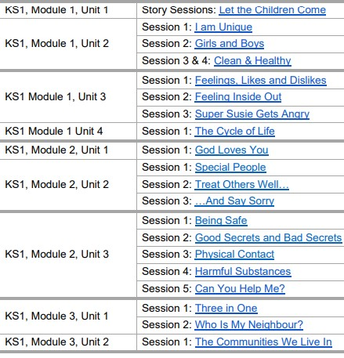 |  | 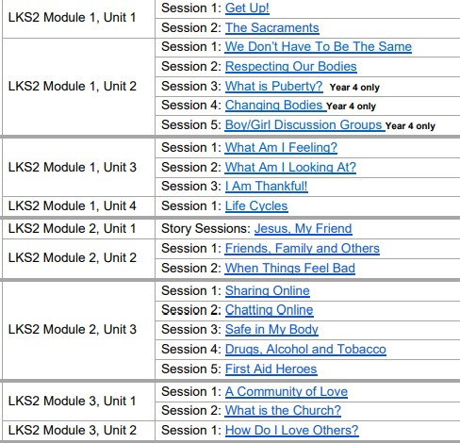 |  | 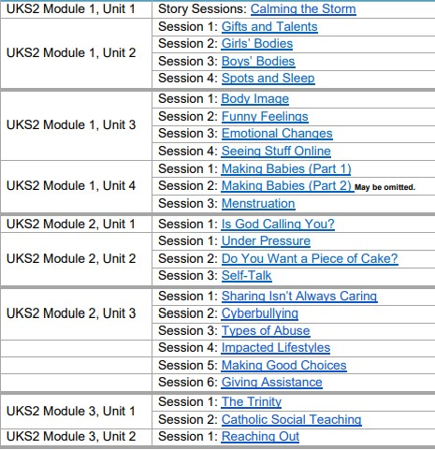
P.E | Flight  Ball skills and games  Points and patches  PE Coach  Rocking and rolling  Throwing and catching  Bat/ball skills  Athletics  Partner work | High and low parts  Throwing and catching  Cat/balloon/stars  Pathways  Friends/bubbles/shad  Spin/turn/twist linking movements  Aiming/hitting/kick  Words 3 pigs  Dribbling/hitting/kick  Athletics 1  Group games  Athletics 2 | Stretching and curling  Ball skills  Who am 1?  Symmetry/asymmetry  Explorers/hornpipe  Pathways  Change of front  Creative games  The eagle and fish  Mechanical process  Net/court/wall  Swimming  Striking and fielding Athletics 2 | Balance  Net / court and wall  These shoes / giraffes  Receiving body weight  Balance with rolling  Swimming  Championship Wimbledon  Swimming  Problem solving  Athletics  Striking and fielding  Athletics | Net/wall/court  Swimming  Bridges  Swimming  Gym  Use of limbs spinning and turning  City Life  Games  Ball handling  Invasion Games  Athletics 1  Striking and Field  Athletics 2 | Gym – Invasions games  Fitness  Dance – Aztecs  Athletics  Striking and fielding  Athletics
 |  |  | Swimming
Music | Charanga scheme of music  Hey You!  Rhythm in the way we walk and banana rap  In the groove  Round and around  Your imagination  Reflect, rewind, replay. | Charanga scheme of music  Hands, feet, heart  Ho Ho Ho  I wanna play in a band!  Zootime  Friendship song  Reflect, rewind, replay. | Charanga scheme of music  Let your spirit fly  Glockenspiel stage 1  Three little birds  The dragon song  Bringing us together  Reflect, rewind, replay. | Charanga scheme of music  Mamma Mia  Glockenspiel stage 2  Stop  Lean on me  Blackbird  Reflect, rewind, replay. | Charanga scheme of music  Livin’ on a prayer  Classroom Jazz 1  Make you feel my love  The fresh prince of Bel-Air  Dancing in the street  Reflect, rewind, replay. | Charanga scheme of music  Happy  Classroom Jazz 2  A New Year Carol  You’ve Got a friend  Music and Me  Reflect, rewind, replay.
Spanish | N/A | N/A | Introducing/Phonetics 1  I’m Learning Spanish  Seasons  Musical Instruments  Fruits  Animals  Icecream | Phonetics Lesson 2  Presenting Myself  Presenting Myself  My home  At the Café  Classroom  Romans | Phonetics lesson 3  What is the date?  What is the date?  Do you have a pet?  Clothes  Olympics  Tudors | Phonetics lesson 4  At School  At School  Habitats  The Weekend  Me and the world  World War II

.

